
CAVALLO s.r.l.
via Mulino 5/B - 20090 BUCCINASCO (Milano) ITALY
T.0039.0245101515 Fax 0039.0245100234
e-mail: info@cavallocom.it www.cavallocom.it

LAMINAR FLOW CABINET

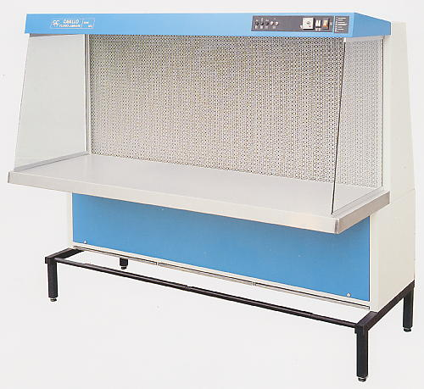
The horizontal laminar flow cabinet are used in Research and Floriculture Laboratories for the following applications : plant tissue culture and medicine preparation, sterile test, assembly of optic components, etc.
They are carefully constructed to prevent contamination from the outside environment as well as cross contamination .
Air passing through a HEPA filter, allows a sterile work environment ( Class 100 )
Technical features :
- Outer case in stainless epoxy painted steel plate with acid and rust-proof ground
- bench in stainless steel 18/8 AISI 304
- Side walls in crystal glass
- Mounting stand in painted steel
- Main filter having an efficiency over 99,99%
- Pre-filters in polyurethane
- Motor fans
- Internal light
Front control panel housing :
- Mains switch
- Reduction/L.A.F. button
- Fluorescent lamp switch
- UV lamp switch
- Safety fuses
Single-phase 220V-50Hz
Electric system according to CEI 62-25 – CE Marking

Model | Internal Dimensions  (W X D X H) mm | External Dimensions  (W X D X H) mm | Net Weight Kg. | Watt
120 | 1200x600x730 | 1270x1000x1640 | 130 | 500
180 | 1800x600x730 | 1880x1000x1640 | 200 | 1000

MADE IN ITALY

